FIGHTING BACK | Self Defence for  Women & Girls
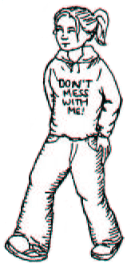
I ONCE MADE A BOOKLET ON SELFDEFENCE FOR MEN, BUT I WANTED TO REDO IT, SO HERE GOES! “SELFDEFENCE IS WHAT WE DO TO MAKE OUR LIVES SAFER ON A DAILY BASIS” IT’S TAKING CONTROL OF SITUATIONS IN WHICH YOU’RE TO BE MADE A VICTIM – THIS RANGES FROM COMMENTS TO PHYSICAL ATTACK. IT’S REALISING THAT IF SOMEONE DOES NOT RESPECT YOUR BOUNDARIES, YOU SHOULD STOP THEM. THERE ARE MANY DIFFERENT STRATEGIES FOR THIS – SAYING SOME THING, YELLING, LEAVING, FIGHTING – THE IMPORTANT THING IS YOU DO SOMETHING.
BODY LANGUAGE
STARING AT THE GROUND, HUNCHED SHOULDERS, HIDING YOUR HANDS IN YOUR POCKETS, MAKING YOURSELF SMALL, CARRIES THE MESSAGE “I’M WEAK & VULNERABLE!” WOMEN GET TARGETED AS EASY PREY, SO HAVING STRONG BODY LANGUAGE DECREASS OUR RISK OF BEING MESSED AROUND. MAKE EYE CONTACT WITH PEOPLE IN A WAY THAT LET’S THEM KNOW YOU’VE SEEN THEM. SWING YOUR ARMS WHEN WALKING, TAKE UP SPACE. STRONG BODY LANGUAGE NOT ONLY AFFECTS HOW OTHERS SEE US, IT INCREASES OUR OWN CONFIDENCE.
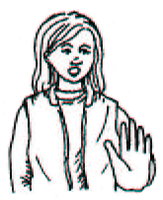
VERBAL STRATEGIES.
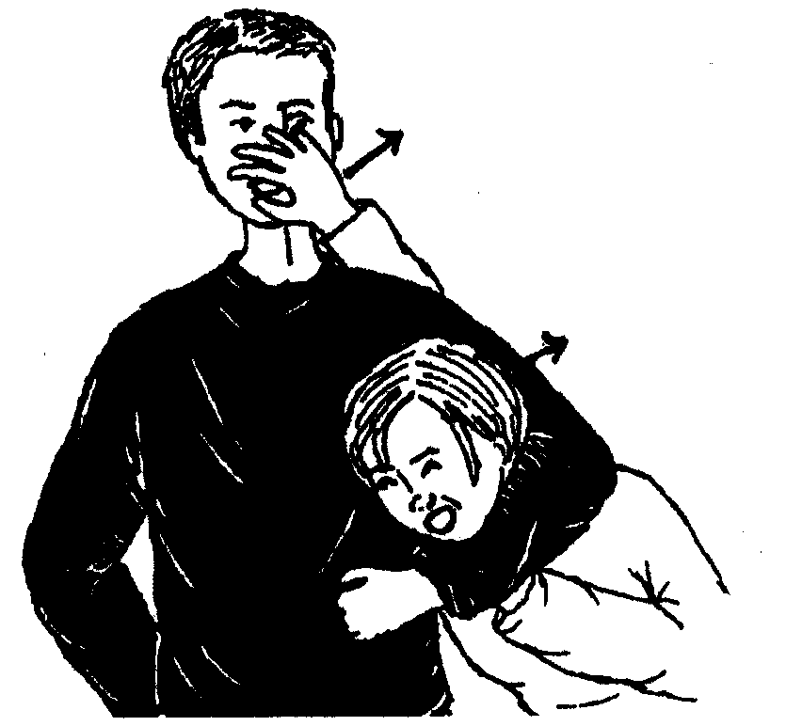
ASSERTING YOURSELF IS AN IMPORTANT PART OF TAKING CONTROL OF YOUR LIFE. IF SOME BEHAVIOUR IS MAKING YOU FEEL BAD, UNCOMFORTABLE. SCARED, CONFRONT THE PERSON. YOU CAN:
- NAME THE BEHAVIOUR
- CRITICISE IT
- TELL THEM WHAT YOU WANT THEM TO DO “YOUR CONSTANTLY TOUCHING ME. I DON’T LIKE IT. STOP IT.” REPEAT IF NEEDED.
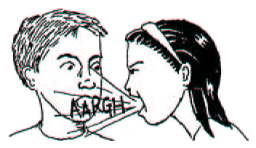
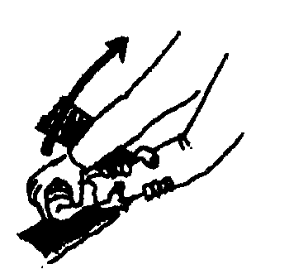
THIS IS A DIRECT NON-ENGAGING WAY OF ESTABLISHING WHAT YOU WANT. AVOID SAYING “PLEASE” ECT WHEN ASSERTING YOURSELF. IF SOMEONE IS BOTHERING YOU IN A PUBLIC PLACE, MAKE A SCENE! IT WILL BE MUCH MORE EMBARASSING FOR THAT PERSON THAN FOR YOU! OUR VOICE IS A WEAPON TOO. YELLING ALERTS OTHER PEOPLE & CAN FREAK AN ATTACKER OUT. IT CAN ALSO HELP CHANNEL YOUR FEAR INTO AGGRESSION. SHOUT “NO” OR “FUCK OFF!” LOUDLY, DEEPLY FROM YOUR STOMACH. REMEMBER, IF YOUR GUT FEELING TELLS YOU SOMETHING DODGY’S GOING ON – SAY SOMEONE UNPLEASANT IS FOLLOWING YOU – TRUST IT AND DO SOMETHING, WHETHER IT’S CONFRONTING THE PERSON, GETTING TO SAFETY, CALLING SOMEONE OR GETTING A WAPON READY.
GETTING RIGHT IN TO SOMEONE’S FACE & SCREAMING WILL THROW THEM.
MOVES THERE ARE SOME TWISTS & TRICKS TO GET OUT OF CERTAIN GRABS.I’LL SHOW YOU SOME BASIC, SIMPLE ONES – I THINK ALL SELF DEFENCE SHOULD BE KEPT AS SIMPLE AS POSSIBLE. YOU CAN PRACTICE THESE MOVES WITH A FRIEND. WITH SOME PRACTICE THEY BECOME AN AUTOMACTIC REACTION. THEY DON’T DEPEND ON STRENGTH, JUST QUICK REACTION & SWIFT MOVEMENT. AND DON’T WORRY IF YOU CAN’T REMEMBER THEM/THEY DON’T MAKE WAYS, E.G. BY STRIKING A PRIMARY TARGET. (SEE NEXT PAGE).
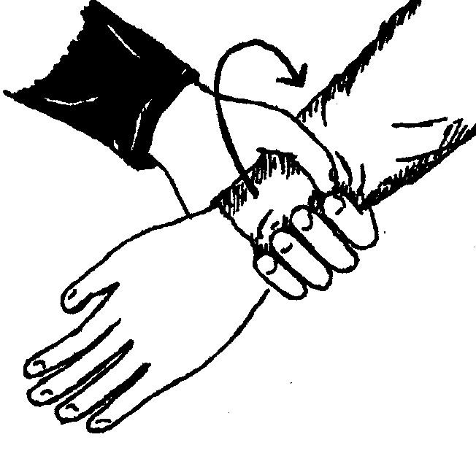
WRIST GRAB IF SOMEONE GRABS YOUR WRIST, GET OUT BY DOING A QUICK TWIST AGAINST THE THUMB (THE WEAKEST PART OF THE GRAB), UP & OVER THE ARM. YOU CAN DO THIS WITH BOTH WRISTS AT THE SAME TIME, TOO.
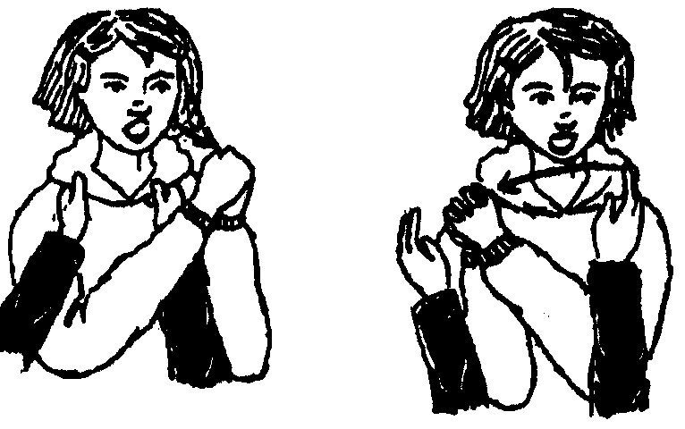
CLOTHES GRAB
THIS ONE IS FOR IF SOMEONE GRABS YOUR SHIRT OR THROAT WITH BOTH HANDS. PUSH ONE HAND THROUGH THEIR ARMS, HOLD YOUR OTHER HAND, AND PUSH QUICKLY FROM ONE SIDE TO THE OTHER. TWIST YOUR HIPS & SHOULDERS TOO TO ADD POWER.
HALF NELSON
THIS ONE IS FOR WHEN SOMEONE GETS YOU INTO A HALF NELSON. GET YOUR HAND UP INTO THEIR FACE FROM BEHIND THIER SHOULDER, THEN JERK THEIR HEAD BACK WHILE COMING UP.
GRABED WITH TWO HANDS
MAKE A FIST, THEN PULL IT UP WITH YOUR FREE HAND, TOWARDS YOUR FACE.
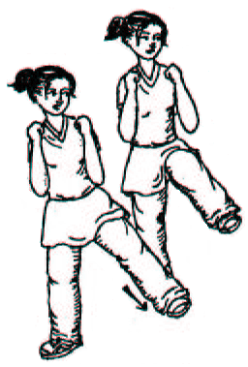
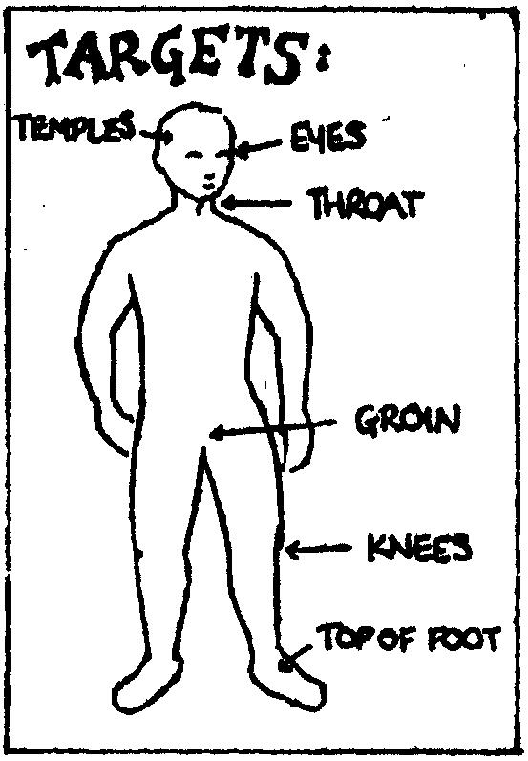
FIGHTING IF YOU CHOOSE TO PHYSICALLY FIGHT, YOU HAVE TO COMMIT 100% & BE AS FIERCE AS POSSIBLE. BELIEVING IN YOURSELF IS AN IMPORTANT PART OF THIS! CHANNEL THE ADRENALINE RUSH OF FEAR INTO ANGER TO MAKE YOURSELF STRONGER, STRIKE, DON’T WRESTLE. THE MOVES SHOWN ARE FOR USE AGAINST THE WAEK PARTS OF THE BODY – ANY ATTACKER, NO MATTER HOW BIG & STRONG, HAS THESE WAK SPOTS. SHOUT WITH EACH STRIKE.
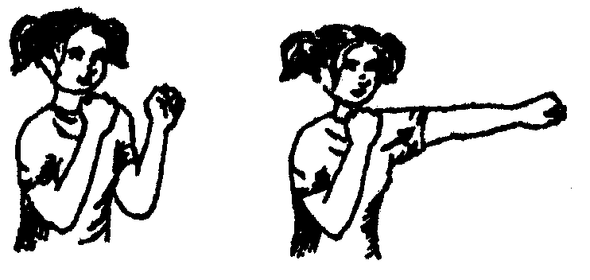
STIKES THE STRAIGHT JAB: MAKING FISTS, BRING YOUR ARM OUT STRAIGHT HITTING WITH THE KNUCKLES FIRST. BRING YOUR SHOULDER & HIP INTO THE PUNCH TOO.
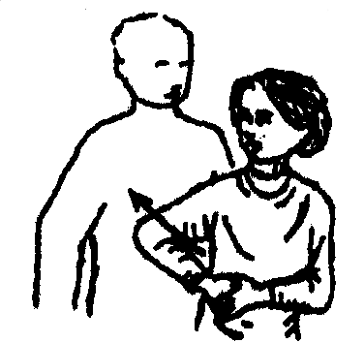
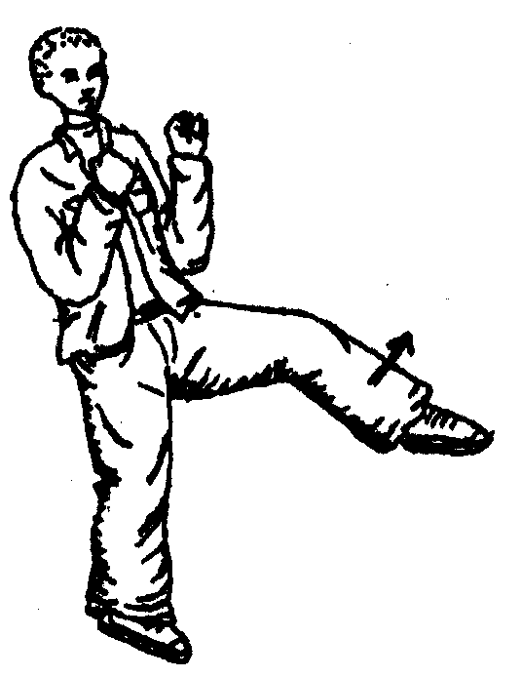
ELBOWS:PULL THE ELBOW BACK HIGH & BRING ACROSS TO YOUR OTHER SHOULDER. MOVE THE HIPS TOO! THIS IS GOOD AGAINST THE TEMPLE, THROAT OR DRIVE YOUR ELBOW INTO SOMEONE BEHIND YOU. PUSH WITH THE OTHER HAND.
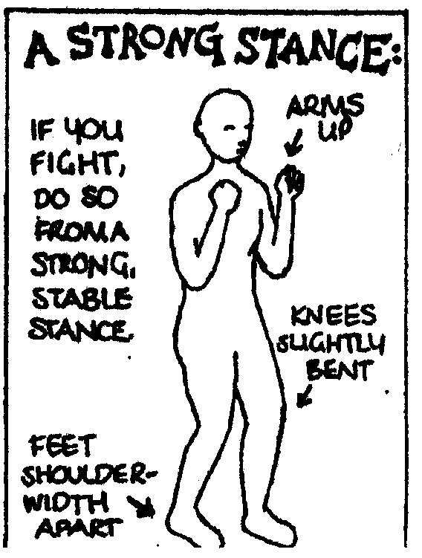
GROIN: PULL YOUR KNEE UP INTO THE GROIN IF YOUR’E IN CLOSE. FROM FURTHER AWAY- BRING YOUR KNEE UP IN FRONT OF YOU. THEN LET YOUR FOOT SNAP OUT. KEEP THE TOES POINTED SO THAT YOU’RE HITTING WITH THE TOP OF YOUR FOOT.

PRACTICE STRIKES AT HOME WITH A SLEEPING BAG.
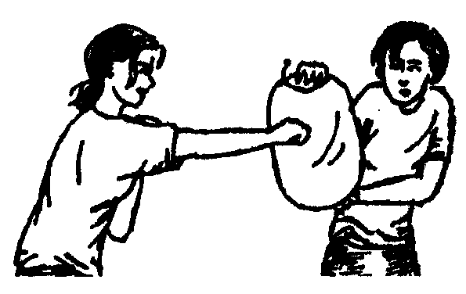
STOMP TO KNEE:
BRING THE KNEE UP AND THEN DRIVE THE FOOT OUT, HITTING THE KNEE. THIS CAN BE DONE FROM THE SIDE, OR FROM IN FRONT, OR EVEN FROM BEHIND.
STOMP TO FOOT:
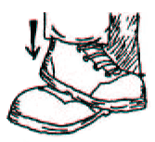
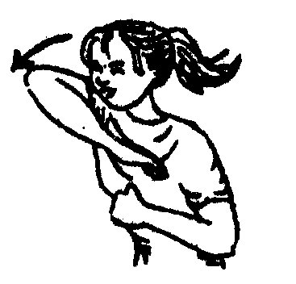
SCAPE YOUR HEEL DOWN FROM THE KNEE ONTO THE TOP OF THE FOOT WITH A STRONG STOMP EITHER FROM BEHIND/IN FRONT/THE SIDE.
STRIKE AT PRIMARY TARGETS WHEN YOU’RE ON THE GROUND.
STOMP TO THE KNEE
KNEE INTO GROIN.
POKE TO EYES.
ELBOW TO THROAT.
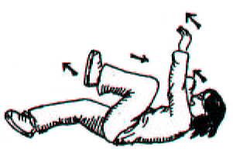
ALSO: BRINGING YOUR KNEE UP WILL HELP KEEP SOMEONE OFF YOU.
A FEW WELL LANDED STRIKES WILL SURPRISE THE ATTACKER & HURT, AND YOU CAN LEG IT AND GET TO SAFETY.
CONCLUSION
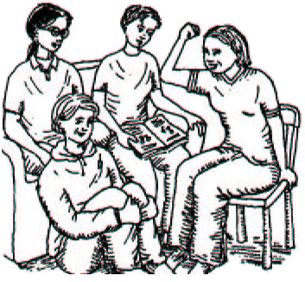
THIS IS JUST TO GIVE YOU SOME IDEAS AND ENCOURAGE YOU TO LOOK AT ISSUES AROUND SELFDEFENCE. DISCUSS IT WITH YOUR GIRLFRIENDS, PRACTICE SOME STUFF, AND LOOK AROUND FOR SELFDEFENCE/ MARTIAL ART CLASSES. SOME CLASSES ARE RUN BY ANNOYINGLLY PATRONISING BLOKES, OR THEY TEACH DEAD COMPLICATED MOVES, OR THEY NEGLECT THE PSYCHOLOGICAL ASPECTS AND VERBAL STRATEGIES. BUT THE IMPORTANT THING IS THAT YOU BUILD UP YOUR CONFIDENCE IN YOUR BODY, AND THAT YOU ARE PREPARED TO ASSERT & DEFEND YOURSELF – REMEMBER, YOU’RE WORTH IT!
WHY NOT START YOUR OWN SELFDEFENCE SESSIONS WITH SOME MATES? EXPLORE THE ISSUES, WARM UP & PRACTICE SOME MOVES, DO ROLE PLAYS, SHARE ANY MARTIAL ARTS SKILLS, CHECK OUT MEN’S SELF DEFENCE BOOKS, SWAP IDEAS. HAVE A LAUGH TOO.
IF WE WANT TO IMPROVE OUR LIVES AS WOMEN, WE NEED TO LOOK AT OUR REALITIES, LEARN SURVIVAL SKILLS AND SUPPORT EACH OTHER. WITH THIS WE CAN FIGHT BACK AGAINST INTIMIDATION & BEING PUSHED AROUND AND TAKE BACK CONTROL OVER OUR LIVES!

